|  |  |
| --- | --- |
| **PHÒNG GD & ĐT TỨ KỲ**  **TRƯỜNG TIỂU HỌC BÌNH LÃNG**  HỌ TÊN:…………………………  LỚP: 4…… | **ĐỀ KIỂM TRA HỌC KỲ 1**  MÔN: **TIẾNG ANH** – LỚP 4  NĂM HỌC: 2022 – 2023  THỜI GIAN: 40 PHÚT |

|  |  |  |  |  |  |  |  |  |  |  |  |
| --- | --- | --- | --- | --- | --- | --- | --- | --- | --- | --- | --- |
| ***Marks:*** | ***Listening*** | | | | ***Reading and writing*** | | | | ***Speaking*** | | ***Total*** |
| ***Q.1*** | ***Q.2*** | ***Q.3*** | ***Q.4*** | ***Q.5*** | ***Q.6*** | ***Q.7*** | ***Q.8*** | ***Q. 9*** | ***Q.10*** |  |
|  |  |  |  |  |  |  |  |  |  |  |  |

**PART I. LISTENING (15 minutes)**

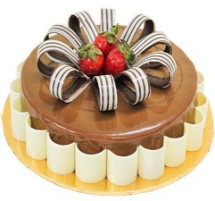**Question 1: Listen and number. (1pt)**

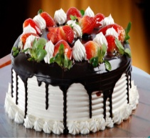

a b c d

a c. . c

March 6

July 26

April 2

January 15

**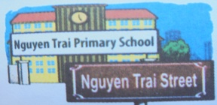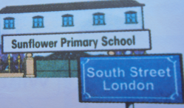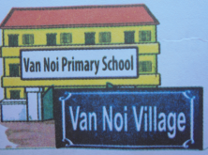Question 2: Listen and tick:( 🗸). (1pt)**

1. a b b c c







. c.

2.

**b**

**c**

**a**

**6**

**TUESDAY**

**8**

**THURSDAY**

**9**

**FRIDAY**

2.

**b**

**c**

**a**

**6**

**TUESDAY**

**8**

**THURSDAY**

**9**

**FRIDAY**

2.

**b**

**c**

**a**

**6**

**TUESDAY**

**8**

**THURSDAY**

**9**

**FRIDAY**

2.

**b**

**c**

**a**

**6**

**TUESDAY**

**8**

**THURSDAY**

**9**

**FRIDAY**

2.

**b**

**c**

**a**

**6**

**TUESDAY**

**8**

**THURSDAY**

**9**

**FRIDAY**

2 a b c

**6**

**TUESDAY**

**9**

**FRIDAY**

**8**

**THURSDAY**







2.

**b**

**c**

**a**

**6**

**TUESDAY**

**8**

**THURSDAY**

**9**

**FRIDAY**

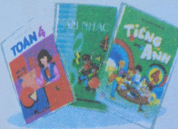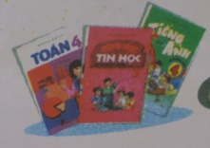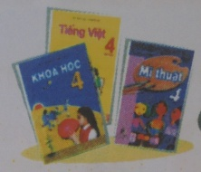3

2.

**b**

**c**

**a**

**6**

**TUESDAY**

**8**

**THURSDAY**

**9**

**FRIDAY**

. a b c







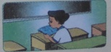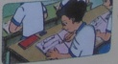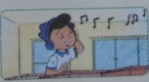4

2.

**b**

**c**

**a**

**6**

**TUESDAY**

**8**

**THURSDAY**

**9**

**FRIDAY**

2.

**b**

**c**

**a**

**6**

**TUESDAY**

**8**

**THURSDAY**

**9**

**FRIDAY**

2.

**b**

**c**

**a**

**6**

**TUESDAY**

**8**

**THURSDAY**

**9**

**FRIDAY**

2.

**b**

**c**

**a**

**6**

**TUESDAY**

**8**

**THURSDAY**

**9**

**FRIDAY**

1.

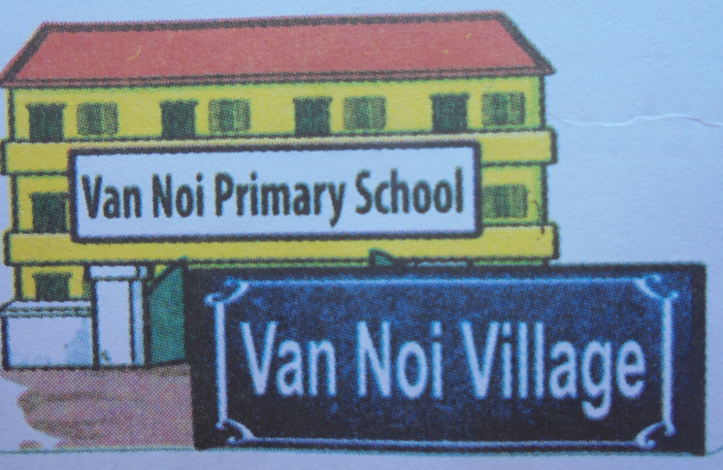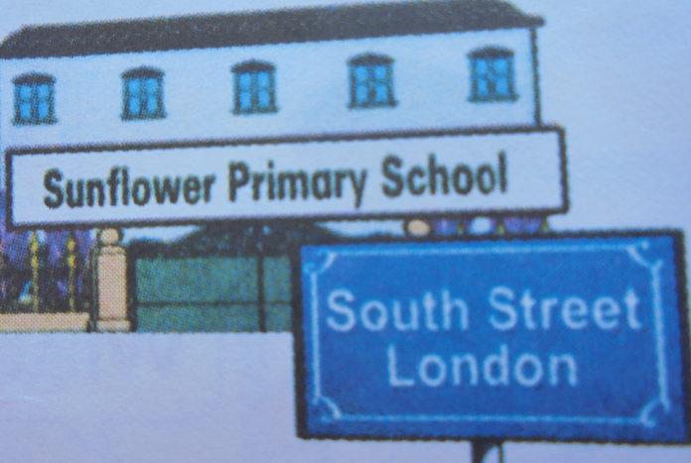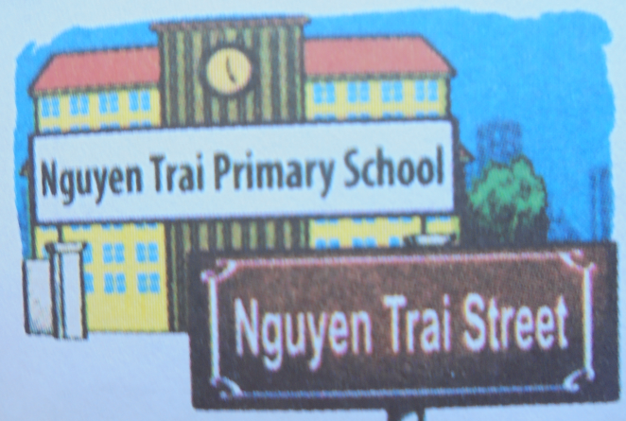

**b**

**c**

**a**

1.



**b**

**c**

**a**

1.



**b**

**c**

**a**

. a b c

a. b. c.

**Question 3: Listen and complete. (1pt)**

What day is it today Tom? It’s **(1)**…………………..

Do you have **(2)**…….……… today? Yes, I do.

What subjects do you have today? I have **(3)**………………..………….Maths and **(4)**………………….

**Question 4: Listen and write T or F in the box. (1pt)**

|  |  |  |
| --- | --- | --- |
|  | **True** | **False** |
| 1. I have English on Saturdays. |  | **F** |
| 2. It’s the fourth of June. |  |  |
| 3. I like flying a kite. |  |  |
| 4. PE is my favourite subject. |  |  |
| 5. She’s reading a text |  |  |

**PART II. READING AND WRITING. (15 minutes)**

**Question 5: Read and write the suitable words in the gaps.(1pt)**

Dear penfriend,

Hi! My name is Mai. I’m nine years old. I’m a pupil at Nguyen Du Primary School.

I’m Vietnamese. I like collecting stamps. I have a lot of stamps. I don’t like playing chess. This is a photo of me. I really want a penfriend.

Please write to me: mai@english.com.vn.

1. Mai is (***0) nine*** years old.

2. She is a pupil at Nguyen Du **(1)**\_\_\_\_\_\_\_\_\_\_\_\_\_\_

3. She likes collecting **(2)**\_\_\_\_\_\_\_\_\_\_\_.

4. She doesn’t like playing **(3)**\_\_\_\_\_\_\_\_\_\_\_\_\_\_\_

5. She wants a **(4)**\_\_\_\_\_\_\_\_\_\_\_\_\_\_\_\_\_.

**Question 6: Fill in each gap with a suitable words from the box. (1pt)**

|  |  |  |  |
| --- | --- | --- | --- |
| Primary | sing | November | Viet Nam |

Hi. My name is Nam. I’m from **(1)** \_\_\_\_\_\_\_\_\_\_\_\_\_. I’m 11 years old. My birthday is on the third of **(2)**\_\_\_\_\_\_\_\_\_\_\_\_.I study at Le Hong Phong **(3)**\_\_\_\_\_\_\_\_\_\_\_\_\_School. I like Music very much. In my free time, I go to Music club. I can **(4)**\_\_\_\_\_\_\_\_\_\_\_\_\_\_ but I can’t play the piano.

**Question 7: Order the words to make sentences (1pt).**

1. go/the/to/school/I/the/ in/ morning.🡪……………………………………….........................

2.visit/grandparents/I/my/morning/in/the/.🡪…………………………………………………..

3.birthday/is/the/on/My/of/July/first/.🡪………………………………………………………

4.have/on/English/I/Monday/Wednesday/and/.🡪……………………………………………

**Question 8: Lookat the picture and the letters. Write the words. (1pt)**

|  |  |
| --- | --- |
| **Tháng 1**   1. Jyarnua🡪\_\_\_\_\_\_\_\_\_\_\_\_\_\_\_\_\_\_\_\_ | IMG_256   1. daMnoy**🡪 \_\_\_\_\_\_\_\_\_\_\_\_\_\_\_\_\_** |
| **What \_\_\_\_\_\_\_\_\_\_\_\_ are you?**   * **I am Japanese**   3. tnlanoiyinta🡪 \_\_\_\_\_\_\_\_\_\_\_\_\_\_\_\_\_\_\_ | khoa-hoc-lop-4  4. Snicece🡪 \_\_\_\_\_\_\_\_\_\_\_\_\_\_\_\_\_\_ |

**PART III. SPEAKING (2pt) (10 minutes)**

**Question 9: Getting to know each other. (1pt)**

**Question 10: Describe a picture. (1pt)**

**THE END**

GV coi: …………………………………. GV chấm: ………………………………….

….……………………………………….. ……………………………………………