|  |  |
| --- | --- |
| **Bình Lãng Primary School**  **Name: .............................................**  **Class: 3.......** | **KIỂM TRA HỌC KÌ II**  **MÔN TIẾNG ANH**  **LỚP 3 - NĂM HỌC: 2017 - 2018**  **Thời gian: 35 phút** |

|  |  |
| --- | --- |
| **Marks** | **Comment** |

**PART 1: LISTENING**

**Question 1: Listen and number. (1 pt)**

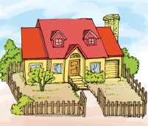 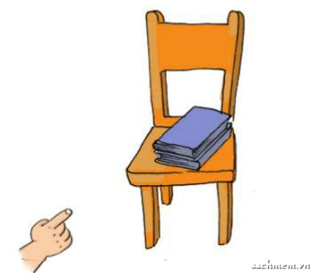 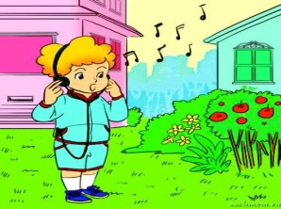 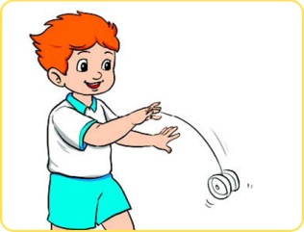

A B C D

**Question 2: Listen and match. There is an example. (1 pt)**

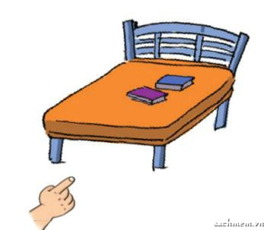 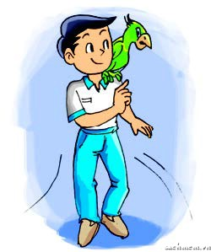 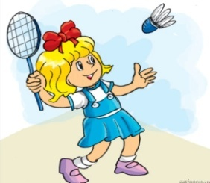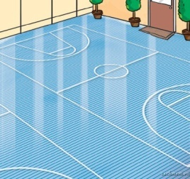

**Question 3: Listen and tick. (1 pt)**

**1.** 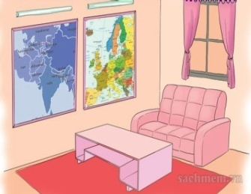A 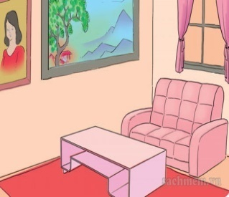B

2. 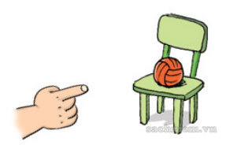A 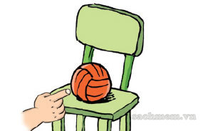 B

3. 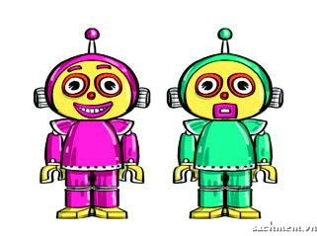 A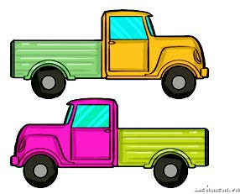B

4. 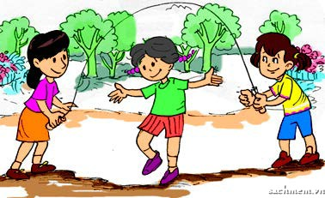 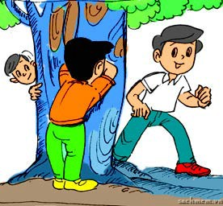

A B

**Question 4: Listen and complete (1pt)**

1. Where is the ______? It’s under the table.

2. What are you doing? I’m ____________.

3. This is my __________.

3. What colour is your pencil? It’s __________.

**PART II: READING**

**Question 5: Look and read. Put a tick ( Description: Description: MC900434665[1]) or cross (X) in the box.** **(1pt).**

|  |  |  |
| --- | --- | --- |
| https://s.sachmem.vn/public/images/TA3T2SHS/U15-L1-2-4-wggbnllvydjfkzyn.jpg | 1. I have a teddy bear. |  |
| https://s.sachmem.vn/public/images/TA3T2SHS/U15-L1-2-5-iomzbfdnesnxrwdh.jpg | 2. Do you like kite? No, I like car |  |
| https://s.sachmem.vn/public/images/TA3T1SHS/U9-L2-2-3-omhqbijxksdqxpnu.jpg | 3. These are my pens. They are green. |  |
| **https://s.sachmem.vn/public/images/TA3T2SHS/U13-L2-2-4-gfggumewlwlrfkuj.jpg** | 4. The pictures are on the wall. |  |

**Question 6: Read and match (1pt).**

|  |  |  |  |  |
| --- | --- | --- | --- | --- |
| 1. This is my grandpa. | **A https://s.sachmem.vn/public/images/TA3T2SHS/U18-L1-2-3-btezbxqobhtnzggb.jpg** |  |  |  |
| 2. There are two bedrooms. | **Bhttps://s.sachmem.vn/public/images/TA3T2SHS/U11-L1-2-3-owhddecgenohfgpp.jpg** |  |  |  |
| 3. She is cooking. | **C** https://s.sachmem.vn/public/images/TA3T2SHS/U12-L1-4-3-orsljtxytpterrmg.jpg**https://s.sachmem.vn/public/images/TA3T2SHS/U12-L1-4-3-orsljtxytpterrmg.jpg** |  |  |  |
| 4. I’ve got three ships | **D Description: tải xuống** |  |  |  |

**PART III: WRITING**

**Question 7: Look at the pictures. Look at the letters. Write the words (1 pt)**

|  |  |  |  |
| --- | --- | --- | --- |
| https://s.sachmem.vn/public/images/TA3T1SHS/U10-L2-4-3-smgqurgrhzttfgdq.jpg | 1. **adbminton** |  | _ _ _ _ _ _ _ |
| https://s.sachmem.vn/public/images/TA3T2SHS/U14-L2-2-3-iolotgcesnpkgqvr.jpg | 2. **fnas** |  | _ _ _ _ _ _ _ |
| Description: images | 3. **nnysu** |  | _ _ _ _ _ _ _ |
| https://s.sachmem.vn/public/images/TA3T2SHS/U12-L2-2-4-ufqwdfkvfbxqzdsm.jpg | 4. **ondp** |  | _ _ _ _ _ _ _ |

**Question 8: Read and write (1 point)**

Today Mai's family is at home. Mai's father is in the living room. He is reading. Mai's sister is listening to music. Mai and her mother are in the kitchen. They are cooking.

**What are they doing?**

1. Mai’s father is ………………………………..
2. Mai’s sister is…………………………………
3. Her mother……………………………………
4. Mai……………………………………………

**PART IV: SPEAKING**

**Question 9+10:**

1. Look and talk (1pt)

2. Point, ask and answer(1pt)

**- THE END –**